|  |  |
| --- | --- |
| **Server & Cloud Security**  Diploma in CSF/IT  Oct 2020 | Week 1 |
| Practical |
| **Call for Solutions #1: Virtual Environment Setup** | |

**1. Introduction**

The rise of the Internet has been one of the most transformative developments in human history. Over two billion people worldwide now have access to vastly more information than ever before, and can communicate with each other almost instantaneously.

How people can request and access information is enabled by the client–server model of computing, which is a distributed application structure that partitions tasks or workloads between the providers of a resource or service, called servers, and service requesters, called clients.

How to ensure the information stored in servers is safe becomes one of the major challenges, which makes server and cloud security become an important topic for all the internet information & service providers.

Our company **SCS** is aiming to setup a secure virtual environment to perform the testing for server security and cloud security tools. Our goal is to learn, evaluate and introduce security solutions to whoever need them.

**2. Purpose of the Call**

This **Call For Solutions** is looking for most relevant and easy-to-use solutions to build a VMware enabled virtual environment and a basic client-server model with at least 2 Windows 2019 servers and 1 Windows 10 client.

**3. Organizer of the Call**

This **Call For Solutions** is organized by the CIOs of the SCS company.

**4. Participant of the Call**

This **Call For Solutions** is aimed for all the project teams. To enter in the running **Call For Solutions**, all the project team members are expected to setup the required virtual environment on their own computers and get familiar with all the necessary steps.

**5. Detailed Requirements**

**5.1 Preparation:**

Download all the necessary resources from Google Drive using the below link:

<https://drive.google.com/drive/folders/0BwxCDAqbajIJc1QxVWlCNWFsYUU?usp=sharing>

**5.2 Task #1: To Have VMware Workstation 15 Installed.**

Hint: Run the installer file to install VMware Workstation 15 on your computer. Accept all the required user agreement to use this software for 30 days’ trial.

**5.3 Task #2: To Create ONE Windows 10 VM and TWO Windows Server 2019 VMs.**

Hint #1: The project teams can have internal discussions to decide the necessary parameters when installing the OS, for example: virtual machine name, location, allocated disk size and etc.

Hint #2: Skip the step when asked for license key, use trial version first.

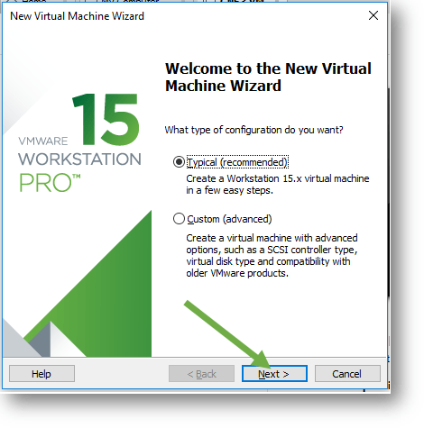 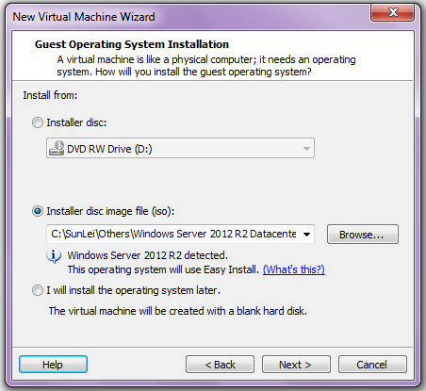

**Prepare for this experience sharing: How did your team install the 2 Windows Server 2019 VMs? Did you install them one by one or you have other quick ways?**

Hint #3: When installing the Windows 10 VM, choose the **Windows 10 Pro** option if promoted.

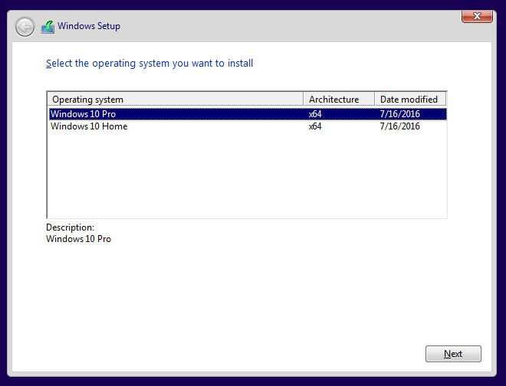

**5.4 Challenge: Setup VMware virtual LAN (Host-only network).**

Host-only networking is one of the VMware virtual networking configuration. It creates a network that is completely contained within the host computer (your PC).

Do some necessary research on how to setup the host-only networking and try it out.

Goal: Put all the 3 VMs in one virtual LAN and ensure they can ping each other.

All project teams are advised to do necessary research and figure out the solution in Week 1.

The suggested solutions will be provided in the next week’s session.

- The End -